Spectrum Wars

Contents
Revision History 4
High Concept 4
Game Overview 4
Platform 4
Target Audience 5
Turns 5
Overview 5
Choosing Who Goes First 5
Structure 5
Actions 5
Purchasing Units 5
Building Construction 5
Unit Movement 6
Unit Combination 6
Upgrades 6
Victory Conditions 6
Conquest 6
Introduction to Conquest 6
Flags 7
Player Designations 7
Flag Carriers 7
Assaulting the Flag Carrier 11
Territory 11
Grid Node Behaviour 11
Resources 11
Territory Control 11
Pixel Refineries 11
Units 12
Triangle 12
Square 12
Pentagon 12
Hexagon 12
Buildings 12
Placing a Building 12
Headquarters 12
Angle Barracks 13
Pixel Refinery 13
Upgrade Construct 13
Combat 13
Initiation 13
Resolution 13
For two identical units 13
For two different units 14
Attacking Buildings 14
Movement 14
Technology Tree 14
Unit Stats 15
Attack Power 15
Defence Points 15
Movement Speed 15
Cost 15
Unit Stat Table 15
Building Stat Table 15
Combining Units 15
Upgrades 16
Square 16
Pentagon 16
Hexagon 16
Berserk 17
Light Speed 17
Tower Defence 17
Controls 17
Interface 18

Revision History
Version Number | Author | Changes | Date
1.0 | Alan Schroeder | Added Information | April 18th, 2009
1.1 | Alan Schroeder | Added Information | April 19th, 2009
1.2 | Alan Schroeder | Added Information | April 23rd, 2009
1.3 | Alan Schroeder | Added Information | April 24th,2009
1.4 | Alan Schroeder | Added Information | April 27th, 2009
1.5 | Alan Schroeder | Added Information | April 28th, 2009
1.6 | Alan Schroeder | Added Information | April 29th, 2009
1.7 | Alan Schroeder | Added Information | May 5th, 2009
1.8 | Alan Schroeder | Added Information | May 7th, 2009

High Concept
The colours are at war! Choose your allegiance and assume command of their army to lead them to victory.

Game Overview
Since the dawn of time, colours have been engaged in a heated battle for control of the colour spectrum. In modern times, the battle has spilled over into computer monitors everywhere. Here they found a valuable resource to utilize: pixels. With this resource the colours are able to forge new weapons of war to use to bring down their enemies.
In this turn based strategy game, players take control of a colour and begin to build their empire. At the beginning, players can only build one basic unit, which they can combine to create lager, more powerful units as they progress through the tech tree. When a unit moves around the map, it leaves a trail of colour behind them. The player’s income at the beginning of their turn grows as they convert more of the map to their colour. The ultimate objective is to destroy the other players, but if one player can control a majority of the map for a predetermined number of turns, they can also claim a victory.

Platform
- PC

Target Audience
- Male gamers between the ages of 13-25
- Casual fans of the Strategy genre
- Turn based strategy fans

Turns

Overview
Spectrum Wars uses turns as a means to control the flow of game play and to allow the player time to think and execute their strategy at their own pace. A Turn does not consist of phases and the player can choose when to end their turn.

Choosing Who Goes First
At the beginning of the game, each player hits a button to generate a random number between 1 and 10, the player who gets the highest number gets to go first. If there is a tie, the players re-roll until there is a clear winner.

Structure
When a player begins their turn, they receive their allotted income for that turn. Once that is complete, they are free to perform any of the following actions, provided they meet the requirements for that action.

Actions

Purchasing Units
During a player’s turn, they have the option of purchasing new units to deploy on the battlefield. They can build as many units as they can, provided they meet the requirements listed below.
Requirements:
- Have at least one open space adjacent to the Angle Barracks
- Have enough pixel resources to purchase a unit

Building Construction
Provided they have the resources to do so, players may construct any buildings unlocked in their tech tree. Any buildings the player wants to construct must be built on a space that is occupied by one of their units.
Requirements:
- Have enough resources to purchase building
- Buildings must be constructed on a space that is occupied by one of their units.

Unit Movement
Each turn, players can move any units they have on the map the number of spaces allowed for that unit (see unit stats for more information). A unit can move in any direction, provided that the space they want to move to is not already occupied.
Requirements
- Unit has not moved yet this turn
- Unit’s path is not obstructed by a building, enemy unit, or edge of map

Unit Combination
As the game progresses, players unlock the ability to combine basic units together to create larger, more powerful units. To combine them, players must first have the new unit plans researched from the tech tree. Once that is finished, they can click on the creation for the new unit and select the basic units that they want to use for creating the new unit. The new unit appears outside of the Research Facility.
Requirements
- Player has the required number of units needed to create the new unit
- Player has enough pixel resources to pay for the procedure

Upgrades
One of the buildings players can construct allows them to have access to certain upgrades to improve their units’ various stats. In addition to unit upgrades, new units can also be researched here.
Requirements
- Player has constructed the Construct building
- Player has the resources required to purchase an upgrade

Victory Conditions

Conquest

Introduction to Conquest
One of the two victory conditions in Spectrum Wars, Conquest involves destroying the opposing player’s Headquarters building, which reveals their flag. Once the building is destroyed the attacking player must pick up that flag and return it to their headquarters. When the player has their enemy’s flag at their headquarters, the enemy army suffers a significant loss of morale. They no longer have the will to fight and lose the game.

Flags
Flags are the focus of this game type and players should take every precaution to defend their flag from their enemy.

Flag Properties
The flag has the following attributes:
- Cannot move on its own
- Has no attack power
- Flags can be placed on top of buildings
- Cannot be built
- Cannot be destroyed
- Does not exist on map until a Headquarters building is destroyed
- Placing a Flag on a building increases the building’s defence points by 2

Player Designations

Attacking Player
The attacking player is the player that has assaulted their opponents Headquarters building and is moving the flag towards their own Headquarters to capture it. While they are transporting the flag, their secondary objective is to keep their flag carrier from being destroyed and having the enemy reclaim their flag.

Defending Player
Once their Headquarters is destroyed, a player is labelled as the defending player. They cannot pick up their flag as soon as it spawns, but must wait for the attacking player to pick it up first before they can try to reclaim it. If they get it back, they can keep moving it around the map, or place it on another of their buildings to increase its defence.

Flag Carriers

Attacking

Picking up the Flag
In order for the attacking player to uncover the flag, they must first destroy the building that houses it, which gives the defending team some time to successfully defend. When the defence points of the Headquarters reaches zero and the building is destroyed, the flag spawns where the building was. Once exposed, the attacking player can move a unit over top of the flag to pick it up.
- Picking up the flag transforms the attacking player’s unit into a mobile fortress that has a different set of attributes.
- The unit remains in this state until:
  - It is destroyed by the defending player
  - The flag is returned to the attacking player’s Headquarters.
- Triangle Units cannot pick up the flag

Moving with the Flag
Moving the flag works just like moving a normal unit; the carrier can move up to 3 spaces per turn.
- The carrier cannot move through buildings
- The carrier cannot move through other units
- Can only move on grid spaces that match the attacking player’s colour

Depositing the Flag
If the flag carrier gets back to the attacking player’s Headquarters, they can deposit the flag to claim victory over their opponents. To deposit the flag, the attacking player has to move the Flag carrier into the Headquarters building to start the transfer.
- Transferring the flag takes three turns once the carrier is inside the headquarters building
- If the headquarters building is destroyed before the transfer completes, the defending player’s flag is ejected and placed in the middle of the map. The Headquarters building behaves normally, exposing the attacking player’s flag for capture.

In the case of both Headquarters being destroyed
If neither player has a Headquarters building to return a flag to, then players have to return their opponents flag to their own flag. The player’s flag must be in their possession for the capture to count. In this instance, victory is instantaneous; there is no transfer time required.

Dropping the Flag
If the defending player successfully destroys the attacking player’s Flag Carrier, it drops the flag it was carrying and the defending player has a chance to pick up their flag.
- Attacking player cannot pick up the defending player’s flag when it is dropped
- The attacking player must wait three turns before they can pick the flag up again

Stats
The attacking player’s Flag Carrier acts more like a building than a unit in combat, but behaves like a unit for movement. There are some restrictions for the Flag Carrier.
- Can only move along tiles that belong to the attacking player
- Cannot attack enemy units, but if they attack and lose, they are removed from the map
- Does not receive any of the bonuses from the stat upgrades (Berserk, Tower Defence, and Light Speed)
- Cannot be used in the creation of a new unit
- Does not convert the grid to the attacking player’s colour
Unit Name | Defence Points | Movement Speed | Attack Power | Cost
Flag Carrier (Attack) | 3 | 3 | N/A | 0

Defending

Picking up the flag
When the defending player’s Headquarters is destroyed and their flag spawns, they cannot pick it up until the attacking player has interacted with it.
- Picking up the flag transforms the defending player’s unit into a Flag Carrier.
- The Flag Carrier remains on the field until:
  - It is destroyed by the attacking player
  - The defending player moves the flag into another building

Moving the flag
Moving the flag works the same as a normal unit, the defending Flag Carrier gets a movement speed of 2.
- The Flag Carrier cannot move through units
- The Flag Carrier cannot move through buildings
- The Flag Carrier can only move along grid spaces that match the defending player’s colour

Depositing the flag
If the defending player has the flag, their Flag Carrier has the ability to drop the flag on top of another building. Doing so will remove the building’s primary function, but provide additional protection for the flag. To deposit the flag on a building, the defending player must move their Flag Carrier on top of a building and right click on the Flag Carrier.
- The Flag Carrier is destroyed once the flag is moved onto the building
- Any building that houses the flag loses its primary function. This means that:
  - Barracks cannot produce units
  - Pixel Refineries cannot provide defending players extra resources per turn
  - Defending players cannot purchase upgrades at the Construct while it houses the flag
- Any building that is housing the flag receives an extra 2 points to its Defence Points

Reclaiming the flag
When the attacking player picks up the defending player’s flag, the defending player’s main objective is to get their flag back into their possession. To do this, they have to reduce the defence points of the attacking Flag Carrier to zero. At zero, the attacking player’s Flag Carrier gets destroyed and the defending player’s flag re-appears on the map for the defending player to pick up.
Defending players can pick up the flag immediately after it drops
Once the unit that touches the flag transforms into the Flag Carrier, their movement count is reset and the Flag Carrier can move its full amount of spaces that turn.

Stats
Unit Name | Defence Points | Movement Speed | Attack Power | Cost
Flag Carrier (Defence) | 4 | 2 | N/A | 0

Assaulting the Flag Carrier
When one or both Flag Carriers are out on the map, players have the opportunity to attack the Flag Carrier to try and reclaim their flag.
- A unit engages combat with the opposing player’s Flag Carrier
- If the attacking unit’s attack value is higher than the defence points for the Flag Carrier, the Flag Carrier loses one Defence Point.
- If the attacking unit’s attack value is lower, the attacking unit is removed from the map.

Territory
The other condition for victory is territory control. In this mode, players must convert two thirds of the map to their colour before the opposing player does.

Grid Node Behaviour
At the beginning of the game, all of the grid nodes are set to the neutral colour. As soon as any unit comes in contact with a node, that node changes its colour to match the player that moved across it. A grid node does not change its colour unless the opposing player moves across it.

Resources
To fund their colour army, players will need to harvest pixels to build new units, construct new buildings, or purchase upgrades. At the beginning of their turn, players receive a set amount of resources, which is then modified by two different variables: How many grid spaces they control, and how many Pixel Refineries they have built.
Total Pixels = Base income + (Grid Squares Owned /3) + 2(Pixel Refineries)

Territory Control
For every three squares that a player controls at the start of their turn (i.e. how many grid spaces are their colour), the player receives 1 extra Pixel.

Pixel Refineries
Each Pixel refinery built by the player gives them an extra two Pixels per turn.

Units

Triangle
Description: The basic grunts for any colour army, these three sided warriors are the building blocks for stronger units. Cheap to build, the Triangle unit is the least powerful and slowest moving of them all. Triangle units cannot cause damage to a headquarter building.
Available: From the Beginning.

Square
Description: One up from the Triangle, the Square is a result of combining two Triangles together. The Square is more powerful than the triangle, but moves just as slow.
Available: Research Square at the Angle Barracks, Combine two units together.

Pentagon
Description: Part of the elite core of the colour army, the Pentagon comes into being when three Triangles combine. Pentagons are not only more powerful than the Triangle and Square, but they also have the ability to move more squares in a single turn.
Available: Research Pentagon at the Angle Barracks, Combine three Triangle units together.

Hexagon
Description: Hexagons are the hero unit for a colour army. Capable of dealing a large amount of damage and moving further than any other unit in a single turn, these units are very valuable, but very expensive as well.
Available: Research Hexagons at the Upgrade Construct, Combine four Triangle units together.

Buildings

Placing a Building
Once a player has the resources to construct a building, they have to move a unit to the location where they want the building, then click on the building icon and select the unit to place the building. Creating a building removes the unit chosen as the location from the map.

Headquarters
Description: The main building for an army, Headquarters provides players with a base income each turn, allows them to construct new buildings, and provides their units with the ability to convert grid spaces to their colour. Players should take every precaution to protect their Headquarters. This building cannot be damaged by Triangle Units.
Available: Players start with one Headquarter building already on the map. To unlock the ability to build another, players must have at least one Upgrade Construct on the map.

Angle Barracks
Description: This building is where all of the units get placed when built. Relatively cheap to build, players can build as many of these as they want, provided that they have the territory to do so.
Available: Unlocked from the start.

Pixel Refinery
Description: A valuable building to have in play, a Pixel Refinery adds additional income for the player to collect at the beginning of their turn. Players need to build a pixel refinery before they can build an Upgrade Construct.
Available: Requires an Angle Barracks and Headquarters on the field in order to build.

Upgrade Construct
Description: Second in importance only to the Headquarter building, the Upgrade Construct is where the player can access all of the upgrades to improve units and resource production as well as the upgrade to gain access to the Hexagon unit. Having an Upgrade Construct also allows to create an additional headquarter building on the map.
Available: Requires an Angle Barracks, Pixel Refinery, and Headquarters on the field to build.

Combat

Initiation
To engage in combat, a player has to be in an adjacent square to an enemy unit or building, and have at least one more move. Attempting to move a unit into the same space as the enemy unit triggers combat, which is then resolved on the spot.

Resolution
Once a player enters combat, each unit generates a random number, based off of its attack stat (see unit stats for more information and specific numbers). Once both numbers are generated, the combat moves into the resolution phase. Here the outcome depends on the difference between the two numbers as well as the difference between the units themselves.

For two identical units
Attacker > Defender: Attacking unit wins, defending unit is removed from the map.
Attacker = Defender: Defending unit wins, attacking unit is removed from the map.
Attacker < Defender: Defending unit wins, attacking unit is removed from the map.

For two different units
Attacker > Defender: Attacking unit wins, defending unit is removed from the map.
Attacker = Defender: The unit with more sides wins; the other unit is removed from the map.
Attacker < Defender: Defending unit wins, the attacking unit is removed from the map.

Attacking Buildings
All buildings have a static defence number and in order to inflict any damage to it, the attacking unit’s attack has to be higher than that defence number. If the unit succeeds, the building’s defence number goes down by one. Once the building’s defence number reaches zero, it is destroyed and removed from the map.

Movement
Units are limited in the number of spaces they can move in one turn (see Unit stats for specific numbers), but the player can move any and all of their units that number of spaces each turn. Units can only move up, down, left, or right, and have to go around buildings and other units.

Technology Tree
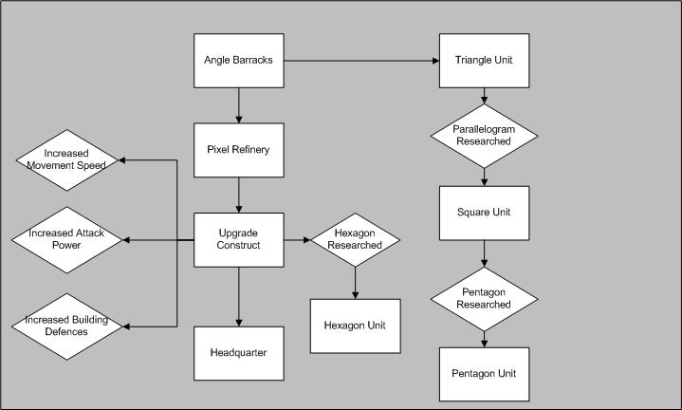
Figure 1: Technology Tree (rectangles represent physical objects, Diamonds represent upgrades)

Unit Stats

Attack Power
This stat determines the random number range for when the unit is involved in combat. The standard range is 1-6, which is then modified by this stat. For example, a unit with an attack stat of 2 gains +2 to their attack range, increasing it to 3-8.

Defence Points
The defence points represent how much durability a building has. When attacked, the attacking unit’s attack must be higher than the defence points of the building to be successful. Once a successful attack is completed, the targeted building loses one Defence point. Buildings that have zero Defence points are destroyed and removed from the map.

Movement Speed
Each unit has a specific number of spaces that it can move in one turn. Once a unit has moved, it cannot be used to create a new unit that turn. Movement is limited to up, down, left, and right. Units cannot move diagonally, through buildings or other units.

Cost
In order to begin production of a unit or building, players need to have the required amount of pixel resources to do so.

Unit Stat Table
Unit Name | Attack Power | Movement Speed | Cost
Triangle | 0 | 2 | 4
Square | 2 | 2 | 10*
Pentagon | 4 | 4 | 15*
Hexagon | 5 | 5 | 20*
*These costs include the price of the Triangle units required to build

Building Stat Table
Building | Defence Points | Cost
Angle Barracks | 2 | 10
Pixel Refinery | 3 | 15
Upgrade Construct | 3 | 20
Headquarters | 5 | 30

Combining Units
In Spectrum Wars, new more powerful units are created by combining multiple basic units together. The Triangle unit is the building block for the larger units. Once the player has researched the ability to construct a new unit, they can build it by clicking on the unit icon, then selecting the required number of Triangle units on the map. Once they are all selected, the units are removed from the map and the new unit can be placed around the Angle Barracks.

Upgrades
Towards the end of the game, players have the option to upgrade the stats for their buildings and units. These upgrades also include the upgrades for building new units. Every upgrade has a cost, prerequisite, a location of where to find it, a description of its function, and a length of how long the research takes to complete.

Square
Description: Re-configures the Angle Barracks to incorporate the creation of Square units.
Prerequisites: Angle Barracks
Upgrade Location: Angle Barracks
Cost: 5 Pixel resources
Research Time: 1 Turn

Pentagon
Description: Further changes the Angle Barracks to create Pentagon units.
Prerequisites: Angle Barracks, Parallelogram Research
Cost: 10 Pixel resources
Research Time: 2 Turns

Hexagon
Description: Enables the Upgrade Construct to produce the powerful Hexagon unit.
Prerequisites: Angle Barracks, Pixel Refinery, Upgrade Construct, Parallelogram Research, Pentagon Research
Cost: 20 Pixel Resources
Research Time: 3 Turns

Berserk
Description: Adds +1 to Attack Power. Berserk applies to all units under your control.
Prerequisites: Barracks, Pixel Refinery, Upgrade Construct
Cost: 20 Pixel Resources
Research Time: 3 Turns

Light Speed
Description: Adds +1 to Movement Speed; applies to all units under your control.
Prerequisites: Barracks, Pixel Refinery, Upgrade Construct
Cost: 20 Pixel Resources
Research Time: 3 Turns

Tower Defence
Description: Adds +1 to all buildings Defence Points.
Prerequisites: Barracks, Pixel Refinery, Upgrade Construct
Cost: 30 Pixel Resources
Research Time: 4 Turns

Controls
Controls for in-game are as follows, navigation of the front end is all done with the mouse and left and right mouse buttons.
Control | Function
W, Up Arrow | Moves the selected unit up one space
D, Right Arrow | Moves the selected unit one space to the right
A, Left Arrow | Moves the selected unit one space to the left
S, Down Arrow | Moves the selected unit one space down
Left Mouse Button | Selects units, Interact with interface (buttons)
Right Mouse Button | De-selects selected unit, cancels button presses

Interface
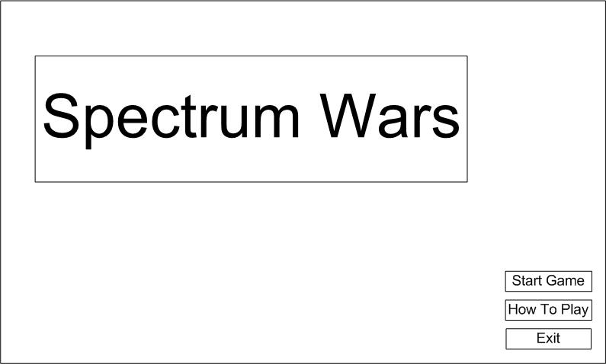

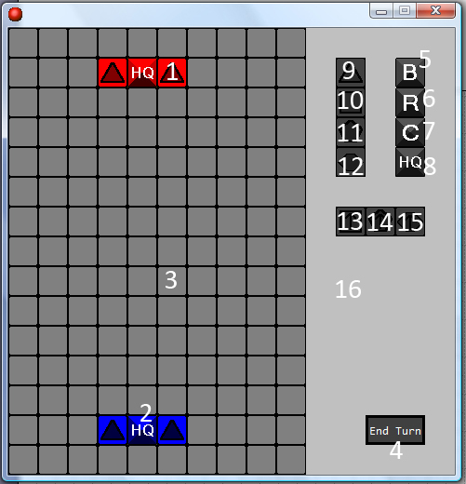
Figure 2: Mock up of Main Menu
Figure 3: Labelled screenshot of the game interface

- Triangle Unit
- Headquarter Building
- Play Area
- End Turn Button
- Build Barracks Button
- Build Refinery Button
- Build Construct Button
- Build Headquarter Button
- Build Triangle Button
- Build Square Button
- Build Pentagon Button
- Build Hexagon Button
- Research Square Button
- Research Pentagon Button
- Research Hexagon Button
- Information Panel
Not Pictured: Berserk, Tower Defence, and Light Speed Upgrade buttons.

